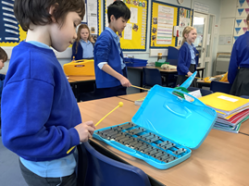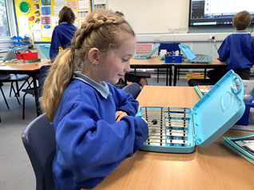

**Intent**

At Budbrooke Primary School, the intention is that children gain a firm understanding of what music is through listening, singing, playing, evaluating, analysing, and composing across a wide variety of historical periods, styles, traditions, and musical genres. We are committed to ensuring the effective delivery of a music curriculum that is accessible to all our children. Music is a practical, creative subject, which should enhance the lives and learning of all children. At Budbrooke, we believe that all pupils can achieve in Music and through learning music, pupils will develop creatively, culturally and spiritually.

Music is planned using Charanga, and where possible, supplemented with cross curricular links from our thematic curriculum to provide extra support and resources to enhance music teaching. Charanga provides many examples of music styles and genres from different times and places. These are explored through the language of music via active listening, performing and composing activities, which enable understanding of the context and genre. Charanga is a scheme of work which offers a topic-based approach to support children’s learning in music. A progression grid has been developed using the key objectives from the National Curriculum and Charanga, which is used by teachers to develop sequential long and medium term plans.

Through our music lessons children are actively involved in a wide range of musical opportunities. Children develop their singing voices, using body percussion and whole body actions, and learning to handle and play classroom instruments effectively to create and express their own and others’ music. Through a range of whole class, group and individual activities, children have opportunities to explore sounds, listen actively, compose and perform.

Music

**Implementation**

* Opportunities for whole school and class enrichment.
* A scheme of work that focuses on specific and relevant vocabulary.
* Clear and comprehensive scheme of work in line with the National Curriculum.
* A scheme of work that focuses on progressive skills and knowledge in performing, understanding and appreciating music
* Participation in local events within the community, and school productions.
* Offer of peripatetic music lessons with specialist teaching of an instrument in Key Stage 2
* A subject leader who monitors teaching and learning to improve standards and outcomes.

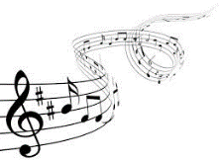



**Impact** Whilst in school, children have access to a varied programme, which allows the children to discover areas of strength, as well as areas they might like to improve upon.

* Children will understand and apply subject specific vocabulary
* Children will achieve age related expectations at their end of each academic year.
* Children will retain and build on knowledge and understanding of music.
* Children will have the opportunity to perform and develop musical skills · Children will use music as a form of expression.
* Children will participate in wider musical activities.
* Children will develop a love of music and an appreciation of different music forms.