

**Impact**

At Budbrooke Primary School, the rich and relevant PE curriculum has led to learners being able to confidently develop detailed knowledge and skills across the PE curriculum. This has contributed to their physical development, participation and achievement. They are curious and show confidence in demonstrating a wide range of active skills. The children are able to think for themselves and practise and lead a selection of sports activities, especially the Play Leaders and Well Being Ambassadors who have organised activities for the different year groups and at community events. The children can self assess themselves and are aware of how to develop their sport skills and achieve their personal bests. They have developed a passion for different sports and eagerly participate in PE lessons as well as the host of extra-curricular activities the school has to offer. The children enjoy using the resources and videos available during PE lessons at school as well as representing Budbrooke Primary School in a variety of School Games events.

**Intent**

At Budbrooke Primary School, we aim to provide a high-quality physical education curriculum which inspires all children to succeed and excel in competitive sport and other physically-demanding activities. We provide opportunities for our children to become physically confident in a way which supports their health and fitness. We regularly provide opportunities to participate and compete in sport and other activities which build character and help to embed the values of:

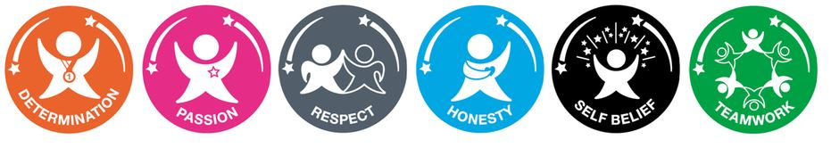

At Budbrooke, we understand that it is important for children to develop fundamental movement skills, become increasingly competent and confident and access a broad range of opportunities to extend their agility, balance and coordination, individually and with others. The children will be able to engage in competitive (both against self and against others) and co-operative physical activities, in a range of increasingly challenging situations and be in charge of their own physical learning journey.

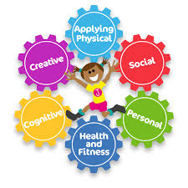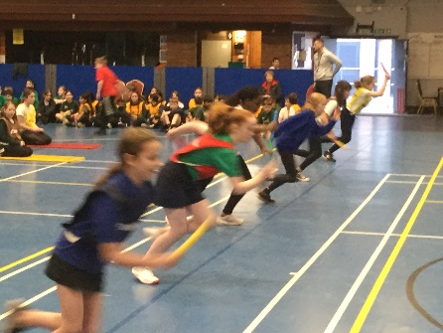

PE

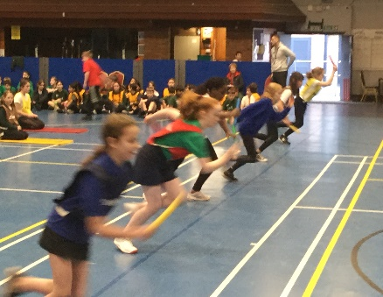

**Implementation**

Teachers at Budbrooke Primary School have good knowledge of PE and use Real PE and a extensive range of quality resources to support the delivery of the PE curriculum.

Each child has two hours of time tabled PE per week where they are supported with developing competence to excel in a broad range of physical activities, to be physically active for sustained periods of time, to engage in competitive sports and activities and importantly lead healthy, active lives. This includes games, skills and dance sessions and the opportunity to run the Budbrooke Mile.

Real PE assessment wheels are used to assess each child’s physical learning.

