**Save the Date: Friday, 3rd February 2023**

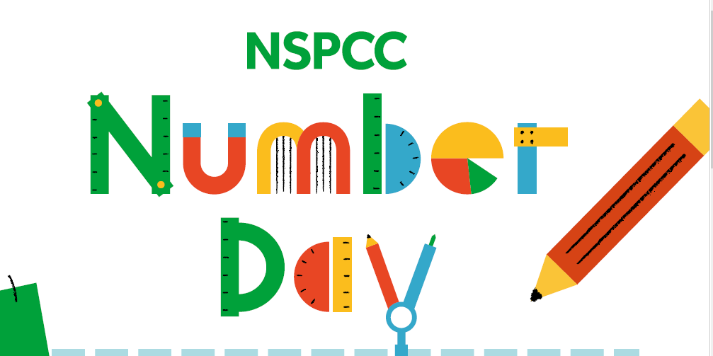

**Dress up for Digits is back!**

**Budbrooke School Council invites children to wear a top with a number or numbers on it.**

**(School uniform trousers & skirts please.)**

**Be creative!**

**Support the NSPCC by donating £2 direct to the charity using this link:**

[**https://www.nspcc.org.uk/support-us/ways-to-give/donate/**](https://www.nspcc.org.uk/support-us/ways-to-give/donate/)