Looking for an activity to keep your occupied over the
Easter holidays?
Budbrooke Librarians would like to invite you to create a 'Book in a Jar' for our library display.

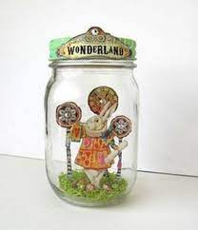
Step 1 - Choose a favourite book.
Step 2 - Find a jar – give it quick wash and dry!
Step 3 - fill/decorate your jar with characters/objects/quotes/pictures/photographs from the book - see below for some inspiration.
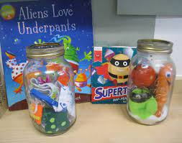
Step 4 - bring your jar back into school after the Easter holidays (wrap in paper or plastic to ensure safe transport!)
Step 5 - Collect your well-earned Stars from Mrs Foreman!

Looking for an activity to keep your occupied over the
Easter holidays?
Budbrooke Librarians would like to invite you to create a 'Book in a Jar' for our library display.

Step 1 - Choose a favourite book.
Step 2 - Find a jar – give it quick wash and dry!
Step 3 - fill/decorate your jar with characters/objects/quotes/pictures/photographs from the book - see below for some inspiration.
Step 4 - bring your jar back into school after the Easter holidays (wrap in paper or plastic to ensure safe transport!)
Step 5 - Collect your well-earned Stars from Mrs Foreman!

