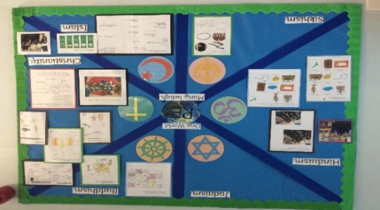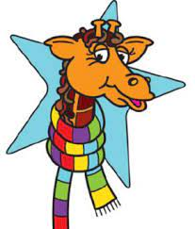

**Useful links to support understanding of RE teaching in school**

<https://www.twinkl.co.uk/resource/religious-education-parent-guide-what-your-child-will-learn-ages-7-11-t-re-7022>

<https://www.twinkl.co.uk/resource/religious-education-parent-guide-what-your-child-will-learn-ages-5-7-t-re-7028>

**Budbrooke’s Religious Diversity Awareness Day:** Each class was given a religion to focus on, they explored that religion in lots of exciting and immersive ways, this included origami, painting, drawing, making puppets, designing patterns and writing fact files. The children used artefacts, stories, images, songs and music to inspire their activities. We had a showcase at the end of the day to celebrate the amazing work completed by each class.

**Implementation**

The R.E. curriculum has been redesigned to reflect our diverse society with a particular focus on Christianity throughout.

**EYFS** will encounter Christianity and other faiths as part of their growing sense of self, their own community and their place within it.

**KS1** will develop an understanding of all 6 principal religions considering personal experiences, special people and the world around us with a particular focus on Christianity.

**Lower KS2** will develop a deeper understanding of all 6 principal religions and appreciate that many people hold non-secular views.

**Upper KS2** will follow a thematic approach progressing to a more detailed examination of similarities and differences between different religions.

R.E. Lessons will build upon prior learning and develop skills year upon year with RE lessons being immersive and interactive wherever possible.

In addition:

The R.E. subject leader will be given training and the opportunity to keep developing their own subject knowledge, skills and understanding, so they can support curriculum development and their colleagues throughout the school. The RE leader also regularly attends Professional Network group meetings.

Assessment of R.E. will be in line with the whole school feedback policy, teachers will assess progress and attainment of R.E

.

R.E

**Impact**

* Children will have a stronger awareness of the world around them and will be mindful of the beliefs of others.
* Children will feel they are valued as individuals and that their beliefs are valued and celebrated.
* Enjoyment of the R.E. curriculum will promote creativity, achievement, confidence and curiosity.
* Children feel safe to learn new things and share their beliefs with others in an accepting environment.
* Children leave the school with a sense of belonging to a tightly knit community where they have the confidence and skills to make decisions, self-evaluate, make connections and become lifelong learners.

**What our children say…**

‘We enjoy open discussions.’

‘Our RE is interactive and fun for everyone.’

‘We enjoy learning about other religions and traditions.’

**Intent**

At Budbrooke Primary School, we have designed our R.E. curriculum with the intent that our children will become resilient, accepting, mindful and inquisitive learners. Our R.E. curriculum allows children to discover and gain an insight into religions within the world that we live. We see the teaching of R.E. is vital for children to understand others beliefs and make connections between their own values. It is our role to ensure pupils are being inquisitive and curious by asking increasingly challenging questions about religion, belief, values and human life.

We will deliver a curriculum that:

* Inspires creative learning through our teaching practices that build on prior R.E. learning and allow for repetition and progression of skills that build upon these starting points.
* Is inclusive, develops self-confidence and identifies that all our children are unique and therefore we should all be tolerant of each other’s beliefs and opinions.
* Encourages our children to be curious about others beliefs developing inquiry based R.E. skills that allow them to be culturally aware of the world around them.
* Promotes equality and understanding of the British values and ensures they are prepared for life in modern Britain.