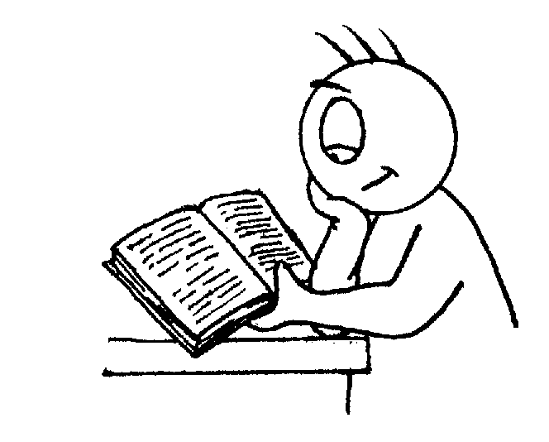

**Writing**

* Vary sentence structure, using different openers.
* Use expanded noun phrases (e.g. biting cold wind).
* Appropriate choice of noun or pronoun.
* Apostrophe for singular & plural possession.
* Comma after fronted adverbial (e.g. Later that day, I heard bad news.).
* Use commas to mark clauses.
* Use connectives to link paragraphs.
* Legible, joined handwriting of consistent quality.

**Reading**

* Give a personal point of view on a text.
* Can re-explain a text with confidence.
* Justify inferences with evidence, predicting what might happen from details stated or implied.
* Use appropriate voices for characters within a story.
* Identify how sentence type can be changed by altering word order, tenses, adding/deleting words or amending punctuation.
* Skims & scans to locate information and/or answer a question.



Number Facts

Don’t forget to practise your number bonds and times tables regularly where appropriate – these will help you meet your end of year expectations

**Mathematics**

* Count backwards through zero to include negative numbers.
* Compare & order numbers beyond 1000.
* Compare & order numbers with 2 decimal places.
* Read Roman numerals to 100.
* Find 1000 more/less than a given number.
* Count in multiples of 6, 7, 9, 25 & 1000.
* Recall & use multiplication & division facts all tables to 12x12.
* Recognise place value of any 4-digit number.
* Round any number to the nearest 10, 100 or 1000.
* Round decimals with 1dp to nearest whole number.
* Add & subtract:
  + Numbers with up to 4-digits using efficient written method (column).
  + Numbers with up to 1dp.
* Multiply:
  + 2-digit by 1-digit
  + 3-digit by 1-digit
* Divide:
  + 3-digit by 1-digit
* Count up/down in hundredths.
* Write equivalent fractions
* +/- fractions with same denominator.
* Read, write & convert time between analogue & digital 12 & 24 hour clocks.

**Budbrooke**

**Primary School**



**End of Year Expectations**

**for Year 4**

This booklet provides information for parents and carers on the end of year expectations for children in our school. The staff have identified these expectations as being the minimum requirements your child must meet in order to ensure continued progress throughout the following year.

All the objectives will be worked on throughout the year and will be the focus of direct teaching. Any extra support you can provide in helping your children to achieve these is greatly valued.

If you have any queries regarding the content of this booklet or want support in knowing how best to help your child please talk to your child’s teacher.

Visit our website at <https://www.budbrooke.warwickshire.sch.uk/> for more information